

PROPOSAL FROM
TEAM GLOBAL EXPRESS Document
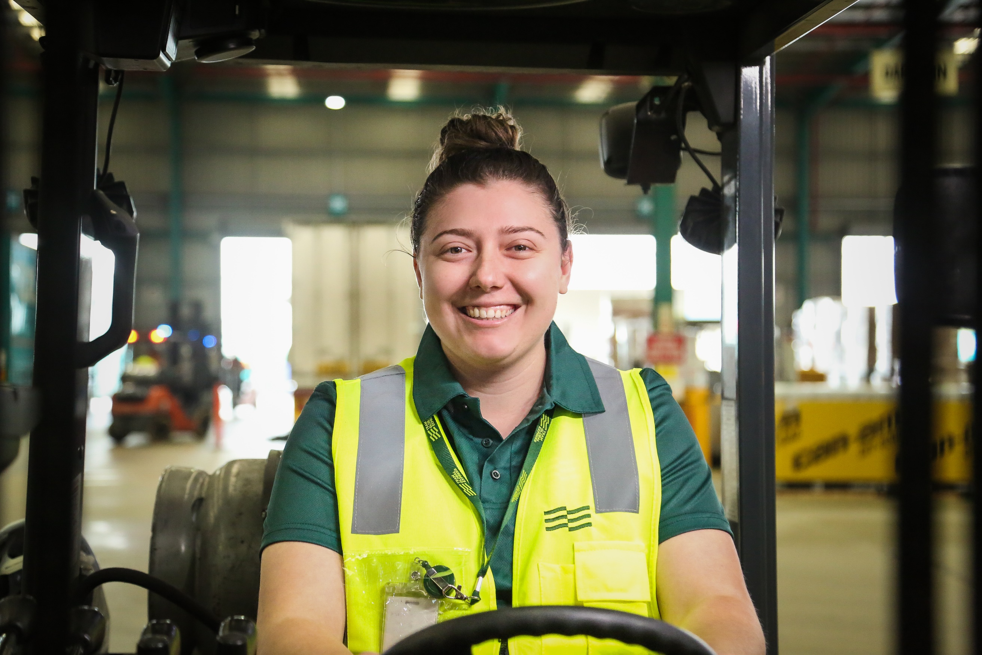

Company Name

Presented to: Customer Name

Presented by: Your Name

Date: Date

Proposal documents

Please take the time to read the following documents in order to understand your rate card and the forms required to arrange an account with Team Global Express Courier.

 | COURIER SERVICE
- Service Offerings
- Courier Vehicle and Service Guide
- Rate Card
- Fees and Surcharges
- New Account Site Details
- Team Global Express Service Conditions

Next steps

To begin our journey together, we recommend taking the next steps:

Please complete and sign all pages in this proposal document applicable to your account.
☐ Rates, fees & surcharge acceptance
☐ Customer site risk questionnaire
☐ New Account Site Details Form
☐ Pallet Policy Form – if required
☐ Dangerous Goods Form – if required

- Once the signed proposal has been completed and returned to your sales representative, you will receive a link to complete an online credit application via Illion – Consumer & Commercial Credit Bureau
- Upon completion of the application, if further information is required you may be contacted by our credit department.
- Once your credit application is approved, your sales representative will be in contact to advise your account code and assist with registration for our online platform, MyTeamGE

Our Services

Point-to-Point Service
Our Point-to-Point Courier Service supports smaller consignments around metropolitan areas. Services include standard, express and priority, with vehicles supporting these services ranging from couriers in the CBD to one tonne trays and vans within Metropolitan Suburbs.

Taxi Trucks
Our Taxi Truck Services supports bulk deliveries through a diverse range of vehicles that include mid to large rigids, curtain-sided and pantech vehicles, power tailgate, semi-trailers, and other specialised transport vehicles.

Fleet Outsourcing
Our Fleet Outsourcing Service caters to large, complex businesses who want to outsource their needs to experts in transport solutions. Our fleet operates from your premises and can be branded giving additional exposure to your business.

Tailored Solutions
Tailored Solutions are designed to the specifications of your business needs. Such services include two-man teams, room of choice installation, assembly, packaging removal and recycling/disposal of replacement items. We support both the B2B (Business to Business) and B2C (Business to Consumer) markets with these services.

More than just your average Courier
VEHICLE AND SERVICE GUIDE – NATIONAL

Vehicle types and capacities – point-to-point

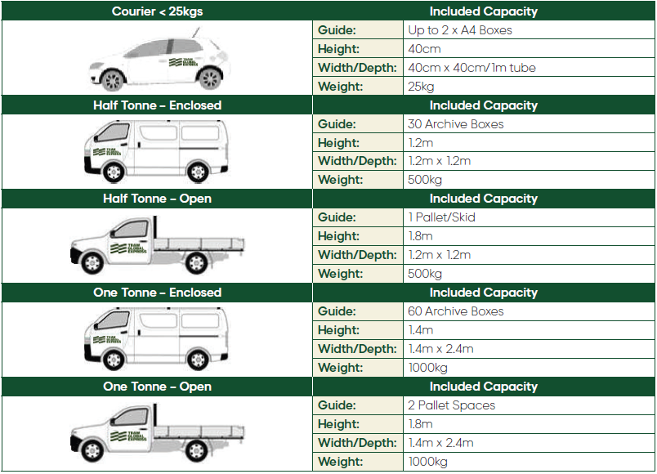
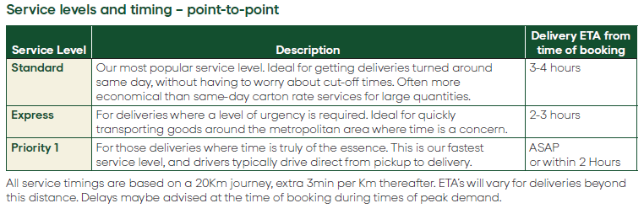

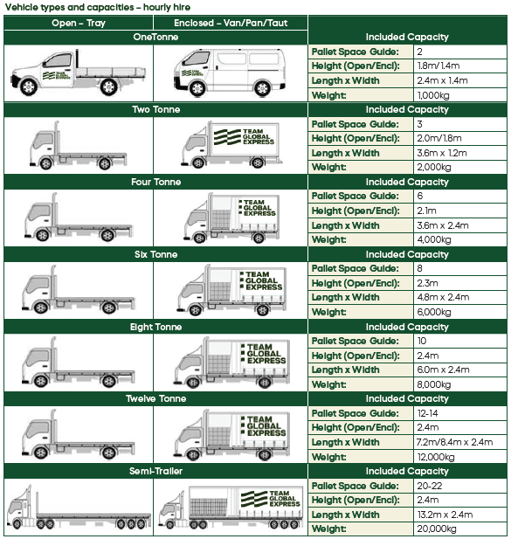
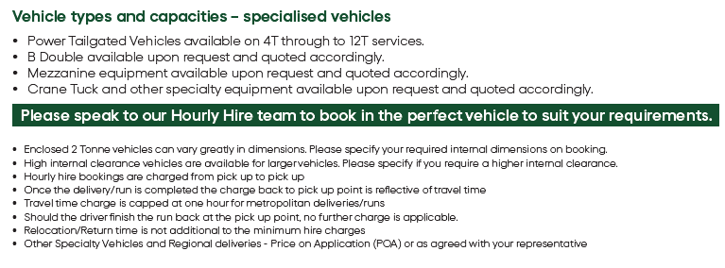

NEW ACCOUNT SITE CONTACT DETAILS | REP NAME & CODE:
EXPECTED TRADE P/WK - PAYMENT TERMS
Expected $ trade per week | $
Payment Terms | 7 days
BILLING / POSTAL ADDRESS DETAILS
Company Name
ABN
Postal Address
Suburb / State / Postcode
Company Phone
Purchase order # or Ref # (If required to appear on mailing address)
ACCOUNTS PAYABLE DETAILS
Contact name - Accounts Payable
Phone Number - Accounts Payable
1st Email address for PDF invoices
2nd Email address for PDF invoices (if required)
3rd Email address for PDF invoices (if required)
DESPATCH DETAILS
Company Name
Site Address
Suburb / State / Postcode
Despatch email to receive PODs
Contact name - Despatch
Phone Number - Despatch
Pallet Management (if YES complete Pallet Policy Form) | ☐Yes ☐ No
Dangerous Goods (if YES complete DG form) | ☐Yes ☐ No
EXECUTIVE CONTACT
Contact name / Number
NEW ACCOUNT FOR EXISTING CUSTOMER (Internal Use Only)
Account Code (Account Code and State)
Rates to be copied from existing a/c in same state | ☐Yes ☐No
If No, refer CRS or negotiated rates in file
OPTIONAL EXTRAS
Paper Invoice ($3.50 p/invoice) | ☐Yes ☐No
Electronic Invoice (no charge) | ☐Yes ☐No
TES (Toll Extra Service) Refer section 7 Service Conditions | ☐Yes ☐No

Customer Site Risk Questionnaire

As part of your initial onboarding with Team Global Express, completing this questionnaire will help us determine whether one of our HSE representatives will visit your facilities to conduct a safety risk assessment.

Please complete by answering the following questions for all sites maintained by your business. If a site does not have one of the below specified safety measures in place, note the answer as “No” and enter the site name in the comment boxes provided.

Company Name: | Number of Sites:
- Does your site have designated loading and unloading zones? | ☐ Yes | ☐ No
- Per the TGE Critical Risk Standards, are loading/unloading zones clearly marked with an exclusion zone and driver safety zones that achieves separation between pedestrians and vehicles / forklifts? | ☐ Yes | ☐ No
Comments:

- Does your site have clear/ unobstructed entry and exit ways to and from loading/unloading areas? E.g. hanging over trees, empty pallets, pedestrian access, shoulder parking bays | ☐ Yes | ☐ No
Comments:

- Does your site have a directional traffic-flow site map including clear signage at entrance point? | ☐ Yes | ☐ No
- Can you provide a copy of this traffic flow site map for the loading/ unloading areas with corresponding vehicle zones clearly marked out | ☐ Yes | ☐ No
Comments:

- Is there a designated point of contact when the Team Global Express driver arrives at the loading/unloading area to provide further instruction | ☐ Yes | ☐ No
- Is a site contact present for early AM and late PM deliveries | ☐ Yes | ☐ No
- Is ample lighting provided if pickup/delivery occurs after dark? | ☐ Yes | ☐ No
Comments:

If any of the above are answered “NO”, please ensure this completed form is emailed to: GEHSE.System@teamglobalexp.com.



Backed by an unrivalled and seamless network, Team Global Express builds unique, innovative and tailored solutions across road, rail, air and sea, providing transport, logistics, and business solutions to customers throughout Australia
and New Zealand.

For more information on how we can support you, contact us via tgexpress.com.au

